**Ceramics 3 Syllabus** Ms. Heida 763-506-8546

[angela.heida@ahschools.us](mailto:angela.heida@ahschools.us)

**Common Art Department Syllabus:**

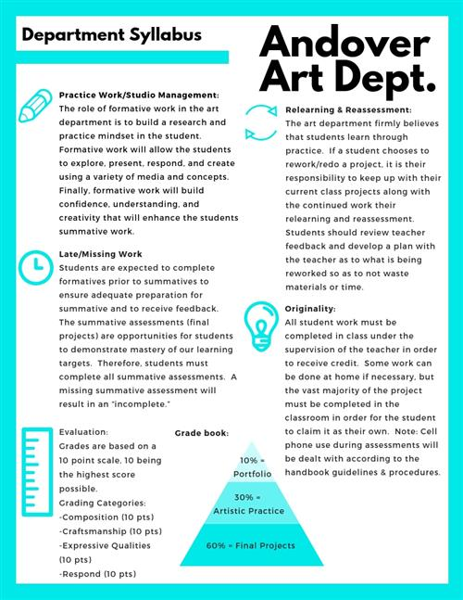Projects:

**Stacking Bowls:** Students will create 3 or more forms that fit inside each other or fit together in some way. They must be complex and have surface variations. (Bowls could have double rims, lids or handles, for example.)

**Material as Source/Sculpture:** Students will create found object sculptures and use them as inspiration for ceramic slab sculptures.

**Art as Source/Altered Pitcher:** Students will study artists and create a self-portrait that they will then paint with underglaze onto their pitcher. Students will alter their pitcher form by removing clay from at least one area and pushing the clay cylinder in or out in at least one area. They will attach a handle and create a pouring lip.

**Everyday as Source/Choice Form:** Students will determine an everyday object to be inspired by and create an artwork of their choice form that reflects that object in some way.

**Colored Clay Piece:**

Students will learn how to mix colored clay bodies together for a “marbleized” effect.

**Tile Surface Experimentation:** On several tile pieces students will practice the following techniques: sgraffito, marblizing, zipper design, bubble glazing, wax resist, paper pattern resist, silicate/crackle surface.

**Surface Study Final:** Students will create a form and then use one or more of the techniques from their tile surface experimentation.

**______________________________________________________________**

**Artists covered:** Linda Christianson, Helga Gamboa, Lucy Yogerst, Dick Cooter, Bill Gossman, Warren McKenzie and others.

If your parent(s) and/or guardians have a special art related talent or work that they would be willing to share with the class, please let me know. It would be an enriching experience for the class.

**Grading:**

**60% Summative Projects, 20% Formative Projects, 20% Studio Performance**

The summative projects receive three grades on a 10 point scale for Craftsmanship, Expressive Qualities and Form. Formative projects receive one grade showing progress toward the learning target. Studio performance is based on a student’s contribution to the art studio and use of work time. You will receive full points if you are on task in class, on time for class, follow school policies on food and phones. If you are ever unsatisfied with a grade please see me and we can discuss how to improve it within grading deadlines. Late work will be accepted until the next projects due date. I do not give extra credit however; you have the option to redo any project for a higher grade within grading deadlines. **All projects must be completed to receive credit for this class.**

School and district policies on cell phone appearance during tests/quizzes result in a zero; and that modifications may be made regarding grading and IEP and 504 plans will be followed.